**ESTABLISHMENT: ARTRO ENERGY**

**INTERNSHIP PERIOD: 7.5.18-23.6.18**

**OBJECTIVE**

To perform predictive maintenance of the 100kW solar plant by collecting data from the surroundings of the PV plant and the inverter and analyse them with proper software. Also, the real-time monitoring of the solar plant is done on a dashboard created.

**INVERTER STUDY**

***Inverter:*** The inverter is the component responsible for converting the direct current (DC) electricity produced by the solar panels into the alternating current (AC) that flows through the grid or powers up the load.

***Types of inverters***

GENERAL CLASSIFICATION:

1. According to semiconductor devices used- SCR, BJT, MOSFET, IGBT, MOS controlled thyristors.
2. According to the connection of semiconductor devices- bridge connected (half and full bridge), series connected, parallel connected.
3. According to the commutation method- line commutated, forced commutated.
4. According to the output phases- single phase and three phase.
5. According to the supply sources- voltage source inverter (VSI), current source inverter (CSI).
6. According to the voltage waveform- square wave inverter, modified sinewave inverter, pure sinewave inverter.

CLASSIFICATION OF INVERTERS IN PV SYSTEM:

1. Stand-alone inverters (supplies stable voltage and frequency to load) – works completely isolated from the grid; used for portable applications.
2. Grid-connected inverters (the most commonly used option)- takes advantage of net metering
3. Bimodal inverters (usually more expensive and are used less often)

Types of Grid-connected Inverter: grid-connected inverters are also classified according to configuration topology.

1. Central inverters, which are usually around several kW to 100 MW range.
2. String inverters, typically rated around a few hundred Watts to a few kW.
3. Multi-string inverters, typically rated around 1 kW to 10 kW range.
4. Module Inverters or Micro Inverters, typically rated around 50 to 500 W.

Central Inverter

This is a PV array that consists of three strings, where each string has three series connected modules. Before these strings are connected to the utility grid, a power conditioning unit is required as an interface between the array and the grid. Designers can use one central inverter where all strings are connected to the DC side of the inverter and the single AC output is connected to the utility grid.

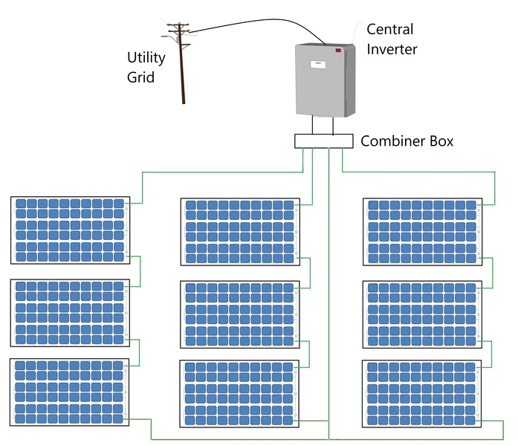

**Figure 1: Central Inverter Topology**

Advantages of a Central Inverter

1. The most traditional inverter topology
2. Easy system design and implementation
3. Low cost per Watt
4. Easy accessibility for maintenance and troubleshooting

Disadvantages of a Central Inverter

1. High DC wiring costs and power loss due to Voltage Drop.
2. Single MPPT for the entire PV system
3. System output can be drastically reduced in case of partial shading and string mismatch
4. Difficult to add strings or arrays for future expansion
5. Single failure point for the entire system
6. Monitoring at array level
7. Huge size - bigger size requires more land and creates a shading issue for the PV array.

String Inverter: In this case, each PV string is connected to a single string inverter at the DC side, and all AC outputs of inverters are combined and connected to the utility grid.

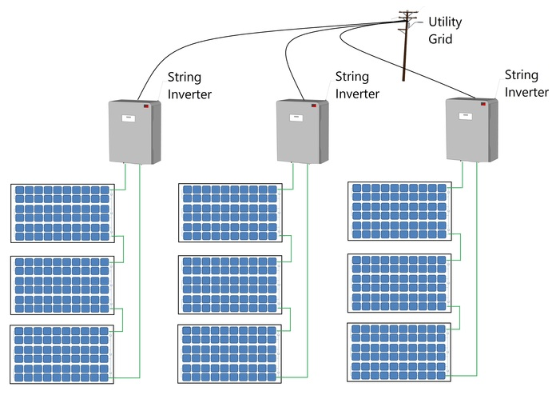

**Figure 2: String Inverter Topology**

Advantages of a String Inverter

1. Smaller in size when compared to central inverters
2. Better MPPT capability per string
3. Scalability for future expansion by adding parallel strings
4. Short DC wires
5. Monitoring at string level

Disadvantages of a String Inverter

1. The installation requires special racking for the inverter for each string
2. Poor flexibility at partial shading
3. Higher per Watt cost than central inverter

Multi string inverter: It utilizes string DC-DC converter for MPPT and then central inverter. This type is not very common.

Micro Inverter: These are also referred to as module inverters. In this case, each module has one dedicated inverter connected on the back of the module. The module DC terminals are connected to the DC side of the inverter and then all AC wires of all terminals are combined and then connected to the utility interconnection point.

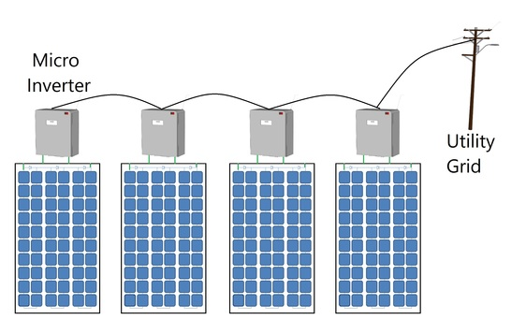

**Figure 3: Micro Inverter Topology**

each module has a dedicated inverter with an MPP tracker.

Advantages of Micro Inverters

1. Resilience to partial shading effects as compared to the central and string inverters.
2. MPPT at module level
3. Highest system flexibility for future expansion
4. Minimum DC wiring costs
5. Monitoring at module level

Disadvantages of Micro Inverters

1. High per Watt cost
2. High maintenance costs
3. Difficult access for maintenance since the installation is under the PV modules

HYBRID INVERTERS:

hybrid inverter (sometimes referred to as a multi-mode inverter) is an inverter which can simultaneously manage inputs from both solar panels and a battery bank, charging batteries with either solar panels or the electricity grid (depending on which is more economical or preferred). Their capabilities may go beyond this however – some devices also handle inputs from wind turbines, generators and other power sources.

 the inverter functions with a battery bank, but also connected to the grid. This dual functionality is the highlight of hybrid inverters that hence enable energy management (smart grid).

**Pros:**

* All-in-one inverter solution for grid-connected solar-plus-storage systems
* Frequently intelligent and programmable for maximising overall system efficiency and savings
* Can usually be installed without batteries for future expansion
* Long history of use in off-grid and stand-alone power systems

**Cons:**

* Less design flexibility than modular solutions which use separate PV and battery inverters
* Generally less efficient than dedicated solar-only or battery-only inverters

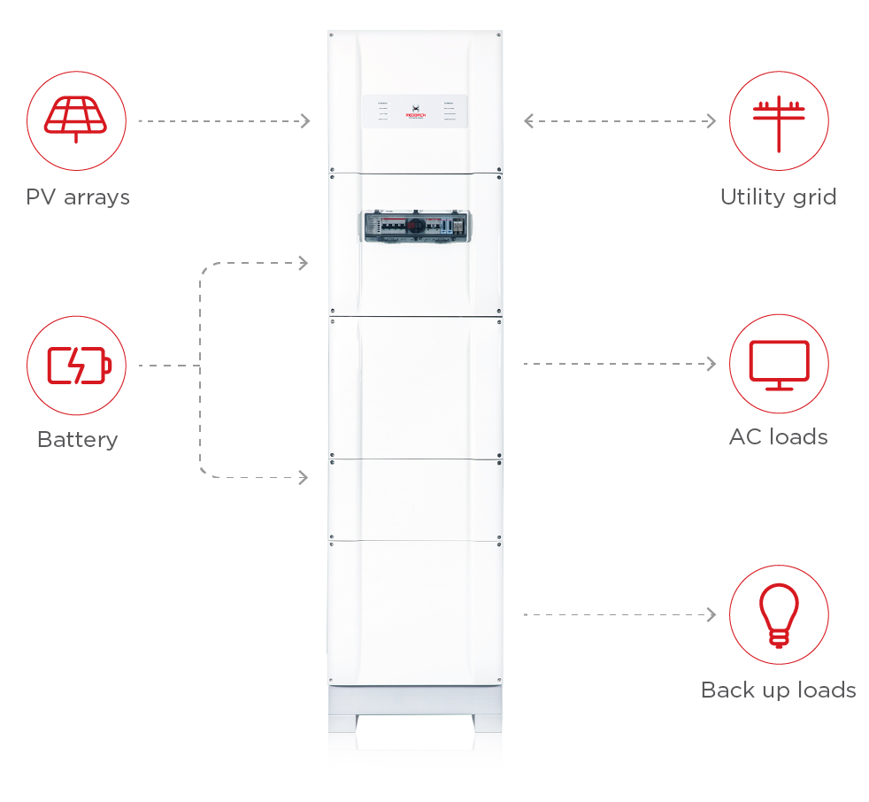

**PV SYSTEM FAULTS:**

In general, there are three levels of faults developed in the PV systems:

* **cell-, module- and string-levels .**

The **cell faults** include mechanical cracks, corrosion by water permeation, and material degradation by ultraviolet or thermal stress.

The **module faults** are related to open-circuits or short-circuits resulting from the degeneration of the cells, cover or sealant materials.

The **PV string faults** consist of open-circuits, short-circuits, mismatch between PV modules, and partial shading.

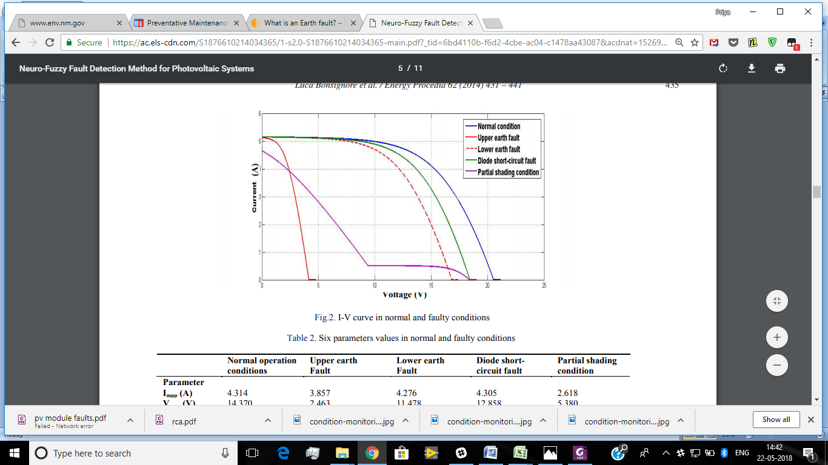

***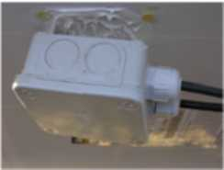* Diode or junction box failures**

The junction box that houses the output terminals & bypass diodes of the PV module, protects these from ingress of water and dust. If the structure of the junction box is compromised or the sealing is not appropriate, rainwater can reach the terminals and corrode them, leading to higher series resistance, lower power output and electric arc or fires.

***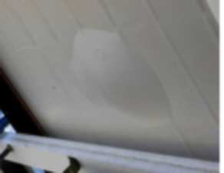*Backsheet degradation**

Backsheets are the first line of defense for PV modules from the back side. In addition to any physical damage, its degradation is mainly caused due to the high exposure of direct UV in the front and transmitted and reflected UV at the back, which causes cracking, yellowing, delaminating, chalking of back sheet and bubble formations. Delaminating at the edge may provide a direct pathway for liquid water to enter a module. Also delaminated areas operate slightly hotter as heat does not conduct out through the back properly.

***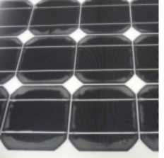*Loss Of adhesion**

Solar cells in a PV module are covered with the encapsulate to provide protection from the operating environment. Ethylene vinyl acetate (EVA) is commonly used for this purpose and also acts as adhesive between the front glass and back sheet. Breaking of the bonds between glass/encapsulate and encapsulate/back sheet are examples of loss of adhesion and also referred to as delaminating.

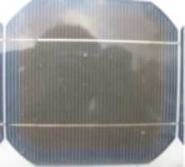**Encapsulant degradation**

The extensive exposure of the solar modules to the sun, results in the degradation of the encapsulant, Degradation of EVA(layer), upon exposure to UV rays and high temperatures, not only causes the discoloration, but also produces aldehydes and acetic acid which can further corrode the metallization on solar cells and the interconnect ribbons.

***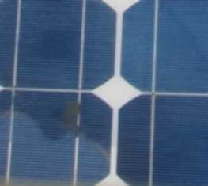*Moisture Intrusion**

Moisture can penetrate in a PV module from the laminated edges or back sheet, resulting in corrosion and increased leakage current. Corrosion results in the failure of contact between the grid lines and cell, causing loss in electrical performance. Presence of moisture in module can also increase the leakage current by reducing the electrical resistance material and resulting in degradation of performance. It can also drop the adhesion strength of bond between various component layers of the module.

**Corrosion of interconnects**

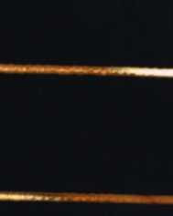Changes into the structure or geometry of the solder-joints due to the segregation of metals (Spy) in the soldering alloy results into interconnect degradation. Such structural changes in the soldering material occur due to thermo-mechanical fatigue resulting into an increased series resistance and reduced performance. In addition to increased series resistance, excessive heating of PV module, hot spot generation, arcing of solder-joint and burning of back sheet are examples of interconnect degradation.

**Increased leakage currents**

Leakage currents caused due to the interconnections or moisture ingress can lead to high voltage safety issues, thus causing safety hazards.

**Thermal degradation**

The extremely high temperatures and electric field experienced by the solar cells in a PV module result into transport of ions, due to which lattice defects are continuously introduced. The generation of these lattice defects in the structure of the solar cells affect the electrical properties of the cell. Temperature degradation mostly results in an increased series resistance or decreased shunt resistance and also leads to the deterioration of the anti-reflective coatings.

**Performance degradation**

Due to delaminating or yellowing, the incident sunlight is unable to reach the cells resulting in performance degradation. Additionally, these defects also impact uniform dissipation of heat resulting into higher operating cell temperatures leading to further damage.

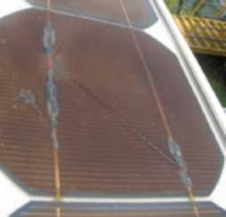 (SEMICONDUCTOR DEVICE DEGRADATION)

**Hot spots** Hot spots occur in a module when its operating current exceeds the reduced short circuit current of a shadowed cell or a group of cells within it. The probable cause of formation of hot spots is the no uniform illumination of the module, individual cell degradation due to cracking or loss of a portion of series-parallel circuit due to interconnect open circuits. It can also be caused due to p-n junction defects and improper handling.

***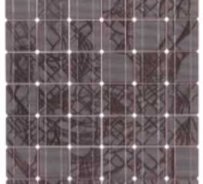*Snail trails**

A snail track is a grey/black discoloration of silver paste on the front metallization of screen-printed solar cells. In the PV module the effect looks like a snail track on the front glass of the module. The discoloration occurs at the edge of the solar cell and along usually invisible cell cracks. The discoloring typically occurs 3 month to 1 year after installation of the PV modules and generally occur due to moisture ingress through micro cracks leading to deposition of silver from fingers and busbars into EVA.

**Broken cell**

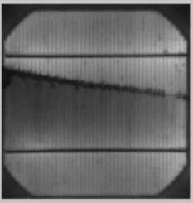Wafer slicing, cell production, stringing and other embedded process during the production of the solar cell and module can cause cell cracks that on further exposure can lead to decrease in output of the modules and form unwanted hot spots. Once cell cracks are present in a solar module, there is an increased risk that during operation short cell cracks can develop into longer and wider cracks causing safety and performance issues.

***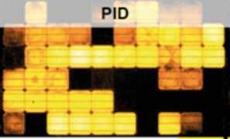*Potential induced degradation(PID)**

Potential Induced Degradation is an undesirable property of some solar modules, which occurs when the module’s voltage potential and leakage current, drive ion mobility within the module between the semiconductor material and other elements of the module (e.g. glass, mount and frame), causing the module’s power output capacity to degrade. The PID is an effect of high voltage stress on long-term stability of solar panels

***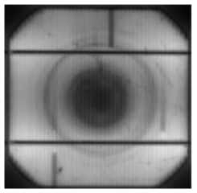*Striation rings**

Striations are growth-induced nonhomogenities that hamper the applications of solid-solution crystals in photovoltaic applications. They are caused by convective instabilities during crystal growth however are not known to impact field operations.

**Light induced degradation**

Light Induced Degradation (LID) occurs in crystalline silicon cells within the first few hours of outdoor exposure and reduces the short-circuit current by 1-5%. The LID effect in crystalline silicon solar cells has been generally attributed to boron-oxygen defects in the boron doped P-type wafer manufactured by the Czocharalski (CZ) process. However this is also not seen as a major field issue in crystalline solar cells and modules

1. EARTH FAULT(ISOLATION FAULT) – The inverter will detect the insulation resistance of the positive & negative input to earth before connecting to grid, if the resistance falls below the setpoint, the inverter will not connect to grid and indicates isolation fault. This is not an inverter fault, the inverter only detects that fault before feeding in, which can appear during initial installation or develop in an existing PV system. If this fault is encountered, we need to check the insulation on DC side.

|  |  |
| --- | --- |
| POSSIBLE CAUSES | EEFECTS |
| * Improper maintenance * short circuit between normal conductor and ground, i.e. a cable in a PV junction box contacting a grounded conductor accidentally * Ground-faults within PV modules, i.e. a solar cell short circuiting to grounded module frames due to deteriorating encapsulation, impact damage, or water corrosion in the PV module | * Improperly detected and interrupted ground-faults can present the risk of fire hazards in solar PV arrays * Excess current flow, including reverse current from adjacent strings, to faulted strings can overload conductors and/or connectors leading to overheating and risk of fire. * Faulted strings can also negatively impact maximum power point tracking, ultimately affecting the **efficiency and power output of the PV array** |

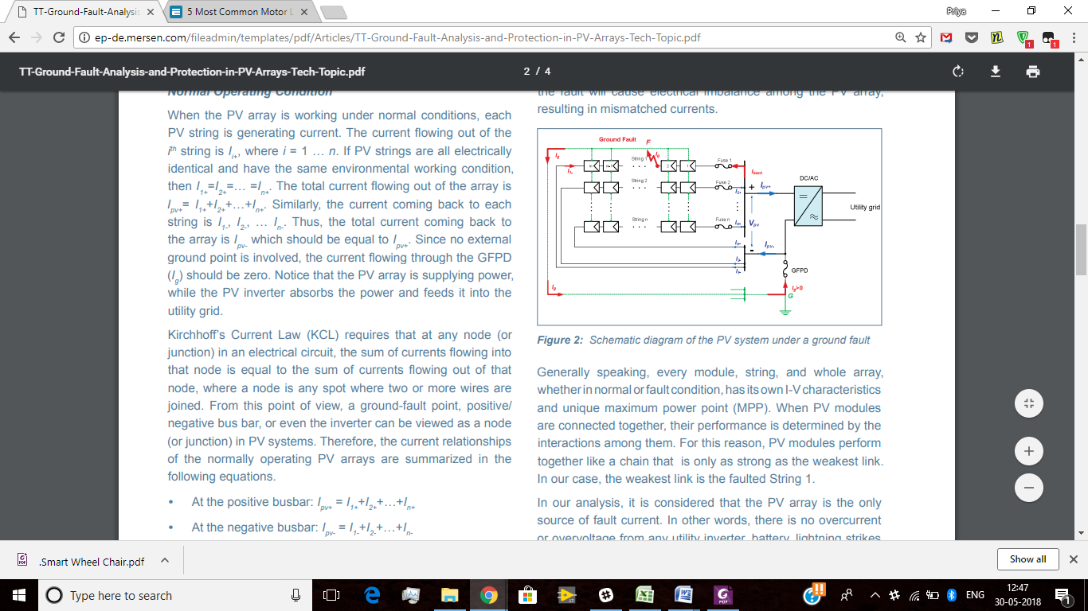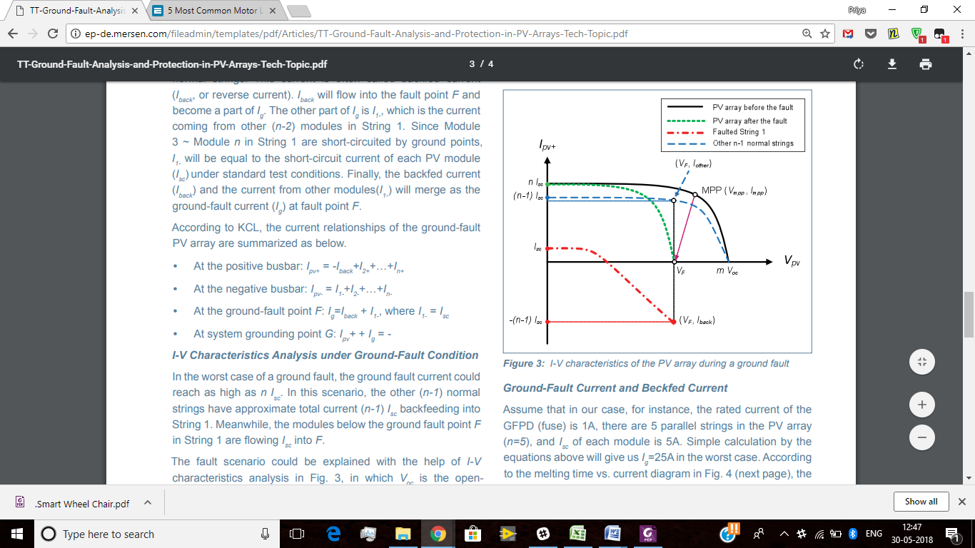

1. BYPASS DIODE FAULT: Damage of bypass diode. ( If one panel is shaded, the current produced by the unshaded panel can flow through a by-pass diode to avoid the high resistance of the shaded panel.   
   By-pass diodes will not be of use unless panels are connected in series to produce a higher voltage.)

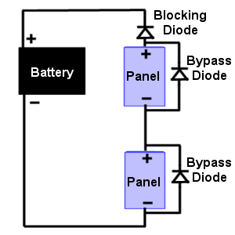

|  |  |
| --- | --- |
| POSSIBLE CAUSES | EEFECTS |
| * Thermal stress * Insufficient cooling * Over voltage and high currents * Not choosing diode of appropriate rating | * Hotspots * When the bypass diode is short circuited it results in power loss |

1. BRIDGE FAULT: When low- resistance connection recognized between two points of different potentials in string of module or cabling, the bridging fault will occur.

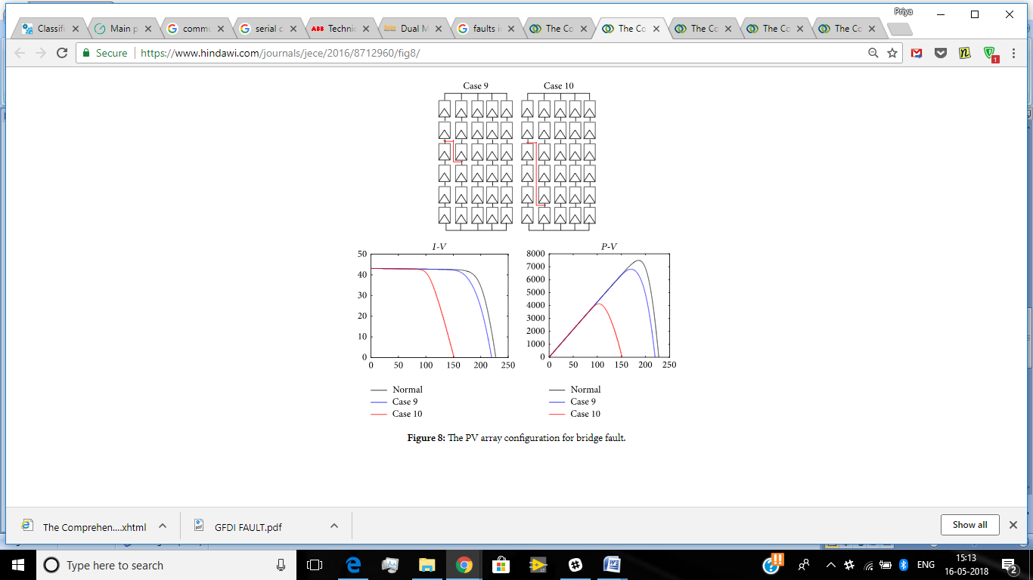

|  |  |
| --- | --- |
| POSSIBLE CAUSES | EFFECTS |
| * mechanical damage * corrosion | decrease in power output ;  poor performance of the pv panel |

1. OPEN CIRCUIT FAULT: An open circuit fault occurs, when one of the current-carrying paths in series with the load is broken or opened.

|  |  |
| --- | --- |
| POSSIBLE CAUSES | EFFECTS |
| poor connections between cells, plugging and unplugging connectors at junction boxes, or breaks in wires cause these fault. | Decrease in output power; |

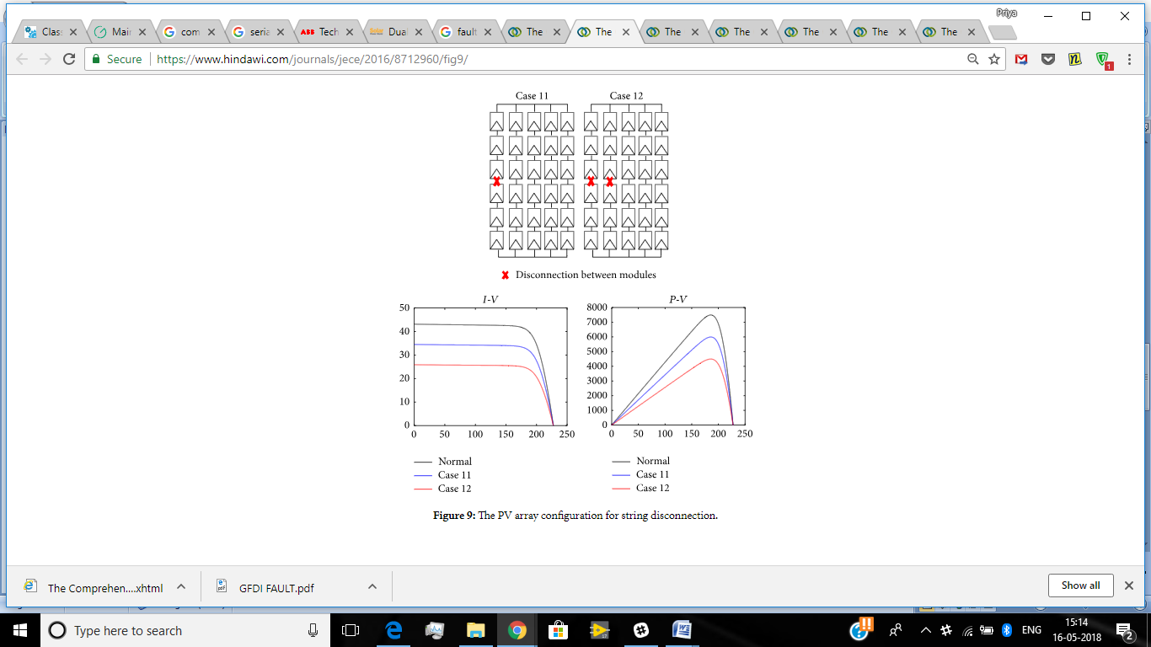

1. MISMATCH FAULT: When the electrical parameters of one or group of cell are changed from other, the mismatches in PV modules will occur.

|  |  |
| --- | --- |
| POSSIBLE CAUSE | EFFECTS |
| Mismatch faults are generally caused by encapsulant degradation, anti-reflection coating deterioration.   * Temporary mismatches –   Partial shading  Various irradiance intensity during the day  Soiling   * Permanent mismatch –   occurs due to faults in hotspot, soldering and degradation(Hot spot heating happens when the operating current exceeds the reduced short circuit current of a shadowed or faulty cell or group of cells within the module) | Decrease in efficiency |

1. ARC FAULTS:

Unsafe arc faults can occur as series or parallel arcs.

A **series arc** can occur when the conductor in series with the load breaks. The series configuration means the arc current cannot be greater than the load current the conductor serves. Typically, series arcs don't develop sufficient thermal energy to create a fire.

|  |  |
| --- | --- |
| POSSIBLE CAUSES | EFFECTS |
| Damaged conductors  Loose or separated connections or terminations  Cracked or corroded solder joints in modules or other components | Short circuited leading to temperature rise |

1. DEGRADATION FAULT:

|  |  |
| --- | --- |
| POSSIBLE CAUSES | EFFECTS |
| browning, delamination, bubbles in the solar module, cracks in cells, defects in antireflective coating and delamination over cells and interconnections | degradation and increasing of the internal series resistance |

**BoS (Balance Of System) FAULTS**

AC & DC CABLE FAULT: Bridging Fault, Open-Circuit fault and Earth Fault are occur in power line carrier and cabling system.

|  |  |
| --- | --- |
| POSSIBLE CAUSES | EFFECTS |
| Thermal expansion and contraction, Loose cables,Undersized cables,Overvoltage and overcurrent.  An aged connection box at the back side of a solar panel or in the corner and bend area of cable cause bridging fault | dropped output voltage and power, and can be dangerous if the leakage currents are running through a person.  Shutdown of one or more PV strings.  Arcs and fire risk. |

AC & DC ISOLATING SWITCHES FAULT:

|  |  |
| --- | --- |
| POSSIBLE CAUSES | EFFECTS |
| Mechanical mechanism Failure, improper design, carbonized contacts | Increase in contact resistance and power losses.   |  | | --- | | Partial or complete shutdown of the PV system | | |

DC COMBINER FAULT:

|  |  |
| --- | --- |
| POSSIBLE CAUSES | EFFECTS |
| Combiner box flooding  Pest intrusion  Failed internal components | variation from required output |

**INVERTER FAULTS**

DEVICES FAULT:

|  |  |  |
| --- | --- | --- |
| **FAULTS** | **POSSIBLE FAULTS** | **EFFECTS** |
| EEPROM fault | the ROM in the internal circuit of inverter is broken | Problem in data storage |
| Mgr EEPROM Fault | master of EEPROM IS broken | Problem in regulating the working of EEPROM |
| Fan fault | improper maintenance | excess heat will cause the insulation system to break down, resulting in decreased life expectancy |
| GFDI fault( ground fault detection interruption) | leakage/ stray current due to electronics components | Causes damage to the  electronics components in the  inverter |
| Isolation fault | Inverter is not well grounded | Produces leakage current |
| Charge controller fault(MPPT) | incorrect operating voltage is fed; improper maintenance | voltage and current from the solar panel to battery is not regulated |
| Fault in thermal resistor | when not operated according to its specifications | Problem in sensing the temperature |
| RCD (residual current device)fault | when not operated according to its specifications | RC outrange cannot be detected |
| DCI fault | DCI current sensor is damaged when not operated according to its specifications | DCI over current protection Fault. |
| Fuse failure | Operating Quantities above  rated value | Inverter shutdown |

PV CONFIGURATION FAULT:

|  |  |
| --- | --- |
| **POSSIBLE CAUSES** | **EFFECTS** |
| mistakes made during initialisation | Incorrect data interpretation |

COMMUNICATION DEVICES FAULTS:

|  |  |  |
| --- | --- | --- |
| **FAULTS** | **POSSIBLE CAUSE** | **EFFECTS** |
| SPI(serial peripheral interface) fault | Improper maintenance | inverter does not communicate with its interfacing devices |
| SCI(serial communication interface) fault | Improper maintenance | inverter does not communicate with its interfacing devices |
| CAN comm. Fault(Controller Area Network) | Improper maintenance | inverter does not communicate with its interfacing devices |
| LCD communication fault | A fault has occurred in the internal communication of the inverter but it continues feeding into the grid. | Incorrect data interpretation |

PARAMETERS FAULT:

|  |  |  |
| --- | --- | --- |
| **FAULTS** | **POSSIBLE CAUSES** | **EFFECTS** |
| overload FAULT | Loads are exceed the standard value | generation of hotspots on the pv panel, operating current exceeds the rated value |
| AC voltage outrange | grid voltage is out of permitted range; high impedance between inverter and fed-in point | excess heat generated |
| Under and over frequency fault | fault in the switches of inverter. | frequency mismatch |
| RC fault | residual current becomes  beyond threshold value; due to defective insulation of electronics components |  |
| harmonics | voltage drops across the switches and modulation of the dc bus voltage | distortion in current and voltage waveform |

PR & CUF calculation:

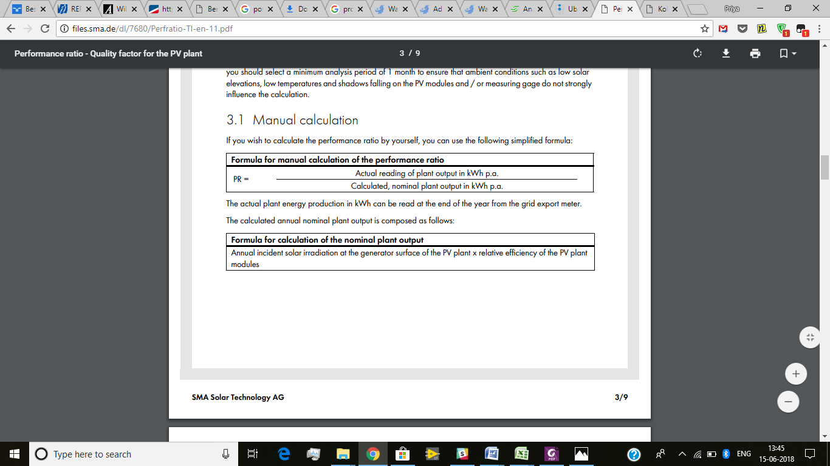

• Analysis period: 1 month (JUNE) = 26days

• Measured average solar irradiation intensity in 1 month: 126.1kWh/m2 (4.85*26)

• Generator area of the PV plant: 69.85 m2

• Efficiency factor of the PV modules: 14.49 %

• Electrical energy actually exported by plant to grid(1 month): 858kWh (33kWh*26)

The irradiation values measured on location yields an average solar irradiation for the entire analysis period of 126.1 kWh/m2.

This irradiation value is extrapolated to the modular area of the PV plant as follows:

Irradiation value in kWh/m2 x plant area in m2 = 126.1 kWh/m2 x 69.85 m2 = 8808 kWh

In order to subsequently calculate the nominal plant output, the irradiation value for the PV plant is multiplied by the modular efficiency: 8808 kWh x 14.49% = 1276.3 kWh

An anticipated nominal plant output of 1276.3 kWh is therefore obtained for the selected analysis period.

However, the actual value for electrical energy exported by the PV plant to the grid is only 858 kWh. If this value and the calculated nominal plant output are fed into the formula for calculating the performance ratio, the following result is obtained:

PR = Actual reading of plant output in kWh p.a. / Calculated, nominal plant output in kWh p.a.

PR= 858/1276.3= 0.67 = 67% (for the month of june, 2018)

The PR value is approx. 67 %. This means that approx. 33% of the incident solar energy in the analysis period is not converted into usable energy due to circumstances such as conduction loss, thermal loss or, for example, defects in components. Here the performance ratio acts as an indicator and can prompt more detailed inspection of the PV plant so that, for example, soiling of the PV modules is removed or defective components can be repaired or replaced.

Rated capacity:  10 kW

generated energy(in the month of JUNE, 2018):  858kWh

Actual number operating days:  26days

Actual number of operating hours: 26days*9.5hr = 247 hours

CUF (%) = [858 / (10 X 247)] X 100 = 34.7%

Studies from Ministry of Non renewable energy (MNRE) India reports that, the average capacity utilisation factor of solar PV plants in India is in the range of 15-19%.

The “specific yield” (kWh/kWp) is the total annual energy generated per kWp installed.

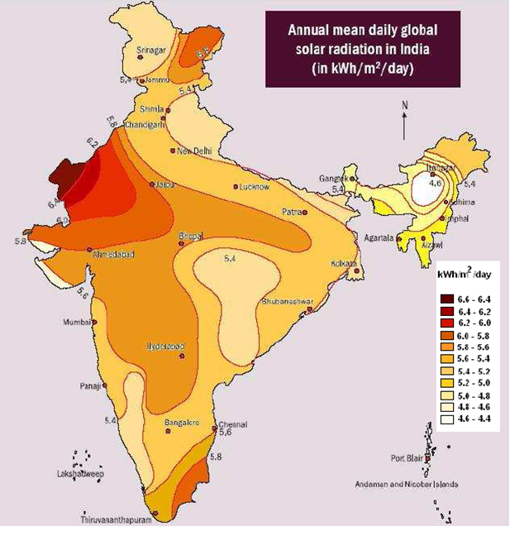

**OUTCOME:**

Comprehensively record, analyze and assess data from all  
components of the solar plant helps to identify performance issues and their underlying causes and also provide timely resolution to the problems and ensure optimum plant performances, smooth operations and prevent energy loss for the owners of Rooftop PV Solar Plant.